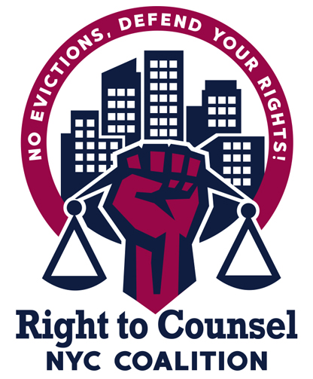
RTCNYC Tool 12.3.3.7 Worst Evictors Week of Action,Talking Points for Worst Evictors

- RTC is really powerful--almost everyone who fights their eviction with a lawyer wins.

- Not enough tenants in the RTC zips know about it and not enough folks are eligible--it’s why we need to pass Intro 1104 and Intro 1529---that would double the income threshold, expand the types of cases covered and make the city work with and fund community organizing groups to help get out the word and help tenants fight back.

- My landlord sues a lot of people (use your borough stats). We want tenants to know that they aren’t alone, and that evictions aren’t their fault. Evictions are about power, not rent---we want tenants to know their power and fight back!

- These worst evictors are serial evictors---they use housing court as a business model to displace, intimidate and scare us.

- Last year, the worst evictors evicted 400 families + in the past 2yrs threatened 12,000 families with eviction.

- Other demands your folks have---No MCIs, repairs, etc.

