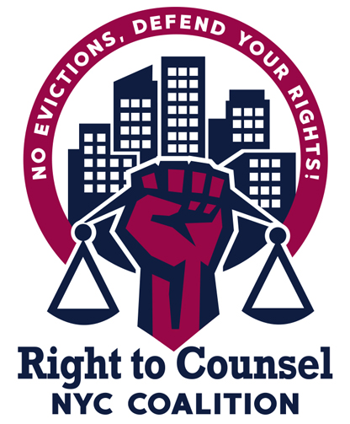
RTC NYC Tool 12.4.6. Outreach email to law schools
Dear ________________,
I'm writing on behalf of the [Tenants-Attorney Pipeline Committee] of the Right to Counsel Coalition in _________ to ask whether [organization/school/career center] would be interested in working with us to host an event at [Name of Law School] regarding the movement to establish the right to counsel in housing eviction proceedings and the numerous job opportunities presented by the creation of this new civil right in many cities across the country.
We are made up of tenant organizing groups, tenant advocates, homeless advocates, senior advocates, disability advocates, academics, legal services organizations and others seeking to build tenant power, challenge landlord intimidation and harassment and to build the movement to fight gentrification and displacement.
As you may know, the movement for Right to Counsel has expanded to cities across the country such as San Francisco, Newark, and Philadelphia. As recently as December 2020, Baltimore’s City Council voted to enact Right to Counsel.
In order to meet this increasing demand for passionate and skilled attorneys in [your city] (and elsewhere), we are working to connect, and recruit law students across the country, especially those who come from communities impacted by gentrification and displacement, to join the movement. We would be eager to also connect with local movements in your community, to build a strong network defending tenants rights.
Please let us know if you would be willing to host representatives from our organization at a law school event to connect with your communities.
Thank you, and we look forward to hearing from you.

