RTCNYC Tool 6.5.1
Template Postcard for Key Decision Makers

One of the ways that we demonstrated widespread support for Right to Counsel was by having members and tenants across the city sign postcards advocating for the right. Here is an example of the postcard we delivered to Mayor de Blasio to pressure him to pass and fund Right to Counsel. We collected seven thousands of these and put them in clear plastic bags for a strong visual effect when it came time to deliver them--we suggest you do the same! You can customize this text to target any lawmaker or key decision maker. We also have the text available in Spanish below!

Postcard Text:
Dear Mayor de Blasio,
New York City is losing its affordable housing stock at a rate faster than we can build. It is your duty to help preserve affordable housing and the best way to do so is to PASS and FUND INTRO 214 which provides the right to counsel in eviction proceedings. In 2013:
• about 30,000 families were evicted from their homes
• two-thirds of those families earned less than $25,000 a year
It costs the city $36,000 a year for a shelter bed, and about $250,000 to build an affordable unit. It costs days lost from school or work, stress, and instability for families. Full representation in housing court costs ~$2,000- $3,200 per case. At a time of heightened inequality, the tale of two cities plays out in Housing Court like nowhere else.
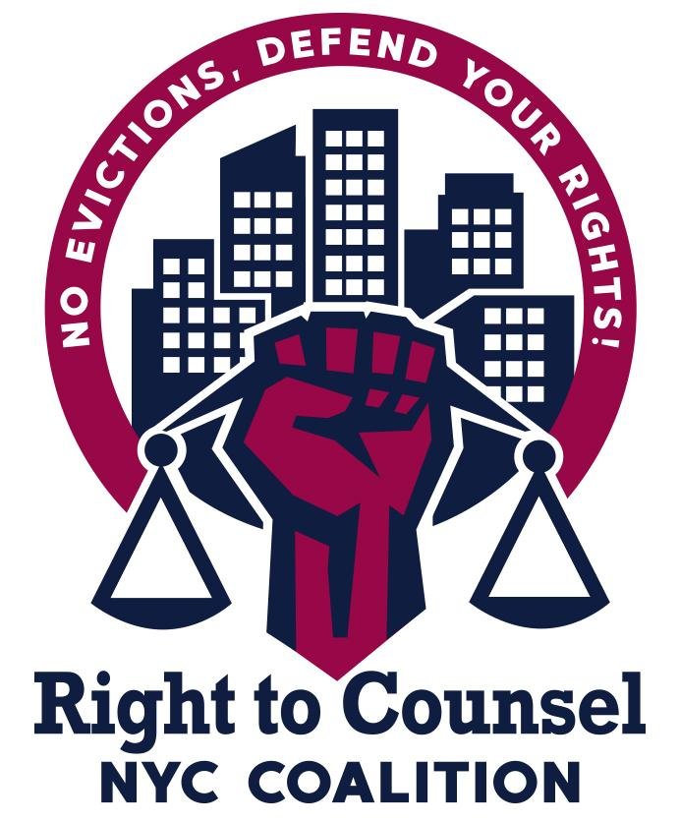
As New Yorkers, we are calling on you to combat inequality, by PASSING and FUNDING Intro 214. It’s a Human Rights issue. Lead the city and the nation in providing equal access to justice and protecting affordable housing. We need to act now by PASSING and FUNDING Intro 214.
PLEASE PRINT CLEARLY:
Name:_____________________________________________
Address: ___________________________________________
City: _______________________ Zip Code: ______________
Phone Number:______________________________________
Email: ____________________________________________

En Espanol:
Estimado Alcalde de Blasio,
La Cuidad de Nueva York esta perdiendo viviendas asequibles mucho mas rápido de lo se puede construir. Es su deber preservar las viviendas asequibles y la mejor manera de hacerlo es de APROBAR y FINANCIAR INTRO 214 que provee el derecho de tener consejo en procedimientos de desalojo. En el 2013,
• Aproximadamente 30,000 familias fueron desalojadas de su viviendas
• Dos– Tercios de esas familias ganaban menos de $25,000 al año
Le cuesta a la cuidad $36,000 al año para pagar una cama en un alberge, y aproximadamente $250,000 para construir una vivienda asequible. Cuesta días perdidos de la escuela, días perdidos del trabajo, causa estrés, y instabilidad familiar. Representación legal completa en un caso de corte de viviendas, estimadamente cuesta $2,000 a $3,200 por caso. La historia de las dos ciuda- des es obvio en la corte de viviendas como en ningún otro lugar.
Como Neoyorquinos, estamos exigiendo que combates inigualdad. APROBANDO y FINANCIANDO INTRO 214 es un asunto de Derechos Humanos. Sea un ejemplo para la cuidad y la nación en ofrecer igualdad de acceso a justicia y protegiendo viviendas asequibles. Necesitamos actuar ahora APROBANDO y FINANCIANDO INTRO 214.
POR FAVOR ESCRIBA CLARAMENTE:
Nombre: ____________________________________________
Dirección: ___________________________________________
Cuidad: __________________________Postal: _____________
Numero de Telefono: __________________________________
Correo Electrónico: ____________________________________

