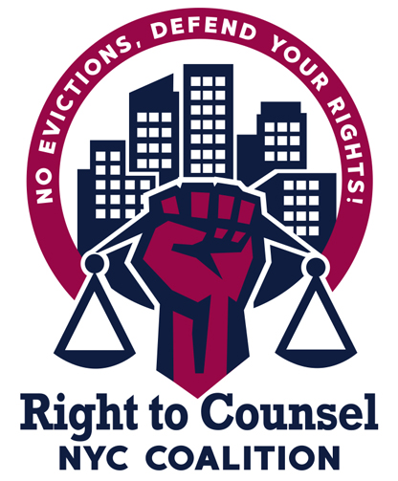
RTC NYC Tool 12.4.7 Orientation for New Lawyers on Right to Counsel

Sample Agenda (1 hour)

- Introductions - name, gender pronouns, role/org, (10 mins)
- Why did tenants fight for a right to counsel? Why did you fight for a right to counsel? (Tenant Leader) (5 mins)
- Show the trailer to the RTCNYC documentary (2 mins)
- How did the RTC coalition win Right to Counsel? What were the campaign tactics? (Tenant Organizer) (5 mins)
- What role did lawyers play in the campaign? (Tenant Attorney) (5 mins)
- Show the tenant leader video (3.5 mins)
- What do you want to see from RTC attorneys? (Tenant Leader) (5 mins)
- What is the RTC coalition organizing around now? Talk about cancel rent, housing courts must change, rent strike etc (Tenant Organizer) (5 mins)
- What are the legal working groups in the RTC coalition working on? (Tenant Attorney) (5 mins)
- Questions (15 mins)
- Closing

