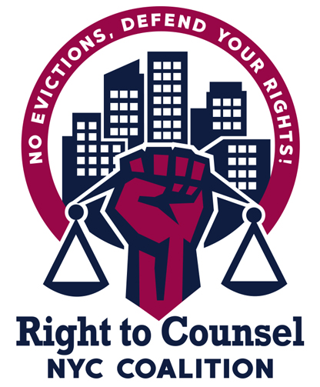
RTCNYC Tool 12.3.3.10 Interactive Activity for Rent Strikes and Non-pays

#1: Talk to tenants about the pros and cons and risks of being sued in court.

Some folks might have individual concerns that they might want to speak to a lawyer about. Like if they’ve been in court a few times before, they run the risk of being sued for chronic nonpayment case, etc., so it would be good to have a lawyer lined up to answer any individual questions folks might have.

#2: Talk to RTC Lawyers

Once you have a sense of how many tenants are involved and how many potential cases it would be, talk to one of the RTC providers in your borough about capacity to represent them all and secure a contact who will help set up intakes and appointments. (Susanna can help you with this if you’d like.)

- Keep in mind, if there are undocumented folks, you can’t only go with LSNYC
- Depending on how many cases it is, you might need to work with more than one organization.

#3: Create an Eviction Defense and Rapid Response Team!!!!

Create an agreement with tenants, that as soon as they get court papers, they should call you (organizer or tenant leader)!!! Create a flyer that reminds them about this. You might also want to create an eviction defense support system, led and coordinated by tenants. You can then connect tenants to an attorney at the organization that agreed to represent them, so they can help tenants answer before they ever go to court. Because you don’t know when landlords file individual cases, you’ll have to do this one by one.
#4: Make Court Cases Political and Collective Action!

Once multiple cases are filed, the attorney can work to get them adjourned to the same day so that all of the cases are on the same day and represented by the same provider. That way tenants can go to court together, you can mobilize around court dates, etc.

#5: Consolidate the Cases and Mobilize!

If there ever is a hearing, the attorney can work to consolidate the cases so it’s all one hearing/trial.

